**Insert School Logo**

**Semester One**

**Examination 2020**

**Question/Answer booklet**

**MATHEMATICS**

**APPLICATIONS UNIT 1**

**Section One:**

**Calculator–free**

|  |
| --- |
| Student Name: _____________________________________ |
| Teacher’s Name: _____________________________________ |
|  |

**Time allowed for this section**

Reading time before commencing work: five minutes

Working time for paper: fifty minutes

**Material required/recommended for this section**

**To be provided by the supervisor**

This Question/Answer booklet

Formula Sheet

**To be provided by the candidate**

Standard items: pens (blue/black preferred), pencils (including coloured), sharpener, correction tape/fluid, eraser, ruler, highlighters

Special Items: nil

**Important note to candidates**

No other items may be taken into the examination room. It is **your** responsibility to ensure that you do not have any unauthorised notes or other items of a non–personal nature in the examination room. If you have any unauthorised material with you, hand it to the supervisor **before** reading any further.

**Structure of this paper**

|  |  |  |  |  |  |
| --- | --- | --- | --- | --- | --- |
|  | Number of questions available | Number of questions to be attempted | Working time (minutes) | Marks available | Percentage of exam |
| **Section One**  **Calculator—free** | **7** | **7** | **50** | **50** | **35** |
| Section Two  Calculator—assumed | 15 | 15 | 100 | 100 | 65 |
|  | | | | Total marks | 100 |

**Instructions to candidates**

1. The rules for the conduct of Western Australian external examinations are detailed in the

*Year 12 Information Handbook 2020.* Sitting this examination implies that you agree to abide by these rules.

2. Answer the questions according to the following instructions.

**Show all your working clearly.** Your working should be in sufficient detail to allow your

answers to be checked readily and for marks to be awarded for reasoning. Incorrect answers given without supporting reasoning cannot be allocated any marks. For any question or part question worth more than two marks, valid working or justification is required to receive full marks. If you repeat an answer to any question, ensure that you cancel the answer you do not wish to have marked.

It is recommended that you **do not use pencil**, except in diagrams.

3. You must be careful to confine your responses to the specific questions asked and to follow

any instructions that are specific to a particular question.

4. Spare pages are included at the end of this booklet. They can be used for planning your

responses and/or as additional space if required to continue an answer.

* Planning: If you use the spare pages for planning, indicate this clearly at the top of the

page.

* Continuing an answer: If you need to use the space to continue an answer, indicate in

the original answer space where the answer is continued, i.e. give the page number. Fill in the number of the question that you are continuing to answer at the top of the page.

5. The Formula Sheet is **not** handed in with your Question/Answer Booklet.

# Section One: Calculator–free 35% (50 marks)

This section has **seven (7)** questions. Attempt **all** questions. Write your answers in the spaces provided.

Spare pages are included at the end of this booklet. They can be used for planning your responses and/or as additional space if required to continue an answer.

* Planning: If you use the spare pages for planning, indicate this clearly at the top of the page.
* Continuing an answer: If you need to use the space to continue an answer, indicate in the original answer space where the answer is continued, i.e. give the page number. Fill in the number of the question(s) that you are continuing to answer at the top of the page.

Working time: 50 minutes

**Question 1 (6 marks)**

(a) Jim purchased 42 metres of fencing to fence off his rectangular garden bed.

Determine the dimensions of his garden bed if the width is half of the length. (2 marks)

(b) Determine the diagonal length of the square shown below.

Leave your answer in square root form. (2 marks)

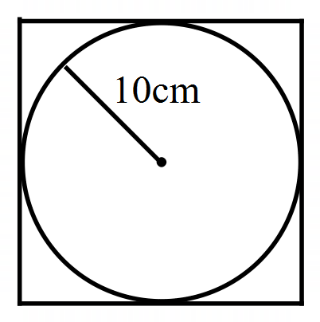

(c) Determine the length of *b* using the letters *t* and *p* for the triangle below. (2 marks)

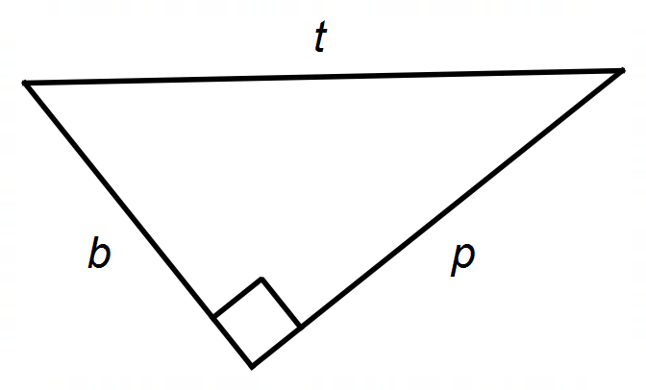

**Question 2 (9 marks)**

Given the matrices below, determine:

A =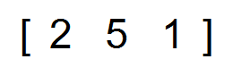 B =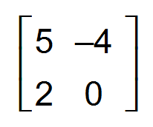 C =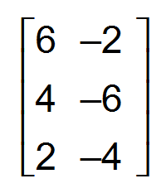 E =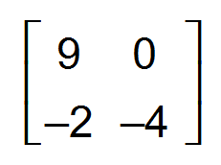

(a) If B + C is possible. (1 mark)

(b) If CA = AC. (1 mark)

(c) 2A (1 mark)

(d) B2 (2 marks)

(e) 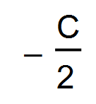 (2 marks)

(f) Matrix D, where D = E - B. (2 marks)

**Question 3 (8 marks)**

Jill works as a fulltime sales assistant for a clothing store and earns $740 for a

37-hour week.

(a) Determine her hourly rate. (1 mark)

If Jill works more than 37 hours in a week, she is paid time and a half for the first three

overtime hours and double time for the remaining overtime hours.

(b) Using the rate in (a) determine her total wage if she worked 43 hours in one week. (3 marks)

Jill deposits 15% of her weekly pay into her Holiday account.

(c) If she earned $800 in one week, determine the amount she deposited into

her Holiday account. (1 mark)

(d) If she deposited $75 into the Holiday account, determine her wage for that week. (1 mark)

At the end of 20 weeks she had $7200 in the Holiday account. Her target was $9000.

(e) Determine the percentage she is short of her target. (2 marks)

**Question 4 (11 marks)**

(a) Simplify the following.

(i) 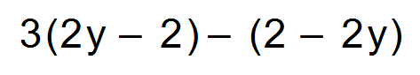 (2 marks)

(ii) 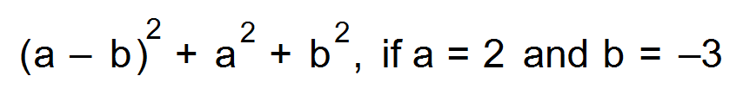 (2 marks)

(b) Given the formula 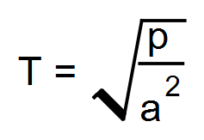 evaluate:

(i) 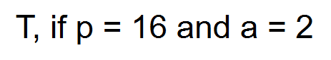 (2 marks)

(ii)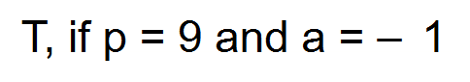 (2 marks)

(c) Determine which machine, X, Y or Z, is more productive.

Circle the correct answer. Show working to support your answer. (3 marks)

Machine X produces 400 units in 4 hours.

Machine Y produces 12 units in 7 minutes.

Machine Z produces 100 units in 50 minutes.

**Question 5 (5 marks)**

The table below shows the number of ways four people can communicate with each other.

(a) Complete the network to reflect the table. (3 marks)

***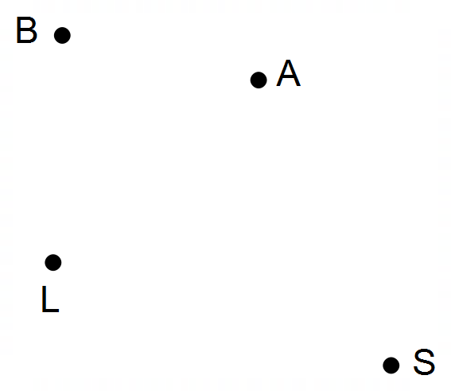* To**

|  |  |  |  |  |
| --- | --- | --- | --- | --- |
|  | **B** | **A** | **S** | **L** |
| **B** | 0 | 2 | 1 | 1 |
| **A** | 2 | 0 | 0 | 1 |
| **S** | 1 | 0 | 0 | 0 |
| **L** | 1 | 1 | 0 | 0 |

**From**

(b) The data from the table above is put into a matrix and called Matrix C.

Matrix C is then cubed and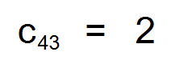.

Explain, with evidence, the meaning of this value. (2 marks)

**Question 6 (4 marks)**

The dimensions of a rectangular prism are shown below.

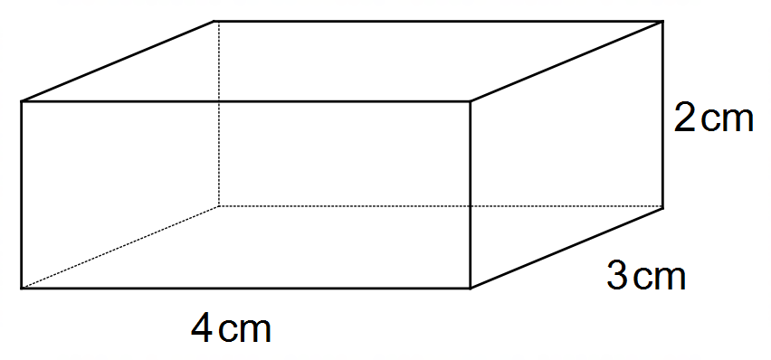

If the dimensions are doubled, determine the following.

(a) The scale factor for the volume from the original prism to the

enlarged prism. (1 mark)

(b) The volume of the enlarged prism. (1 mark)

(c) The surface area of the enlarged shape if the scale factor for the surface

area of the original prism to the enlarged prism is 4. (2 marks)

**Question 7 (7 marks)**

A shop owner uses a 25% mark-up for all of his products.

If the products are not sold within a month he reduces the marked-up price by 40%.

(a) If he purchases a product for $2000, determine the profit, in dollars,

he will make if it is sold within one month. (1 mark)

(b) If the product is not sold within the month, determine:

(i) the price the product will be sold for. (1 mark)

(ii) the percentage profit/loss based on the original purchase price. (1 mark)

(c) The owner sold a product for $650 within a month of purchasing it.

Determine the original price of the product. (1 mark)

(d) If the owner is unable to sell a product by the end of the second month, it will

be discounted further, by 50% of his original purchase price. Determine the

price of the product after two months if his original purchase price was $800. (3 marks)

**End of Questions**

**Additional working space**

Question number(s): ……………………

**Additional working space**

Question number(s): ……………………

**Additional working space**

Question number(s): ……………………

**Additional working space**

Question number(s): ……………….…

WATP acknowledges the permission of the School Curriculum and Assessment Authority in providing instructions to students.